Assignment 4 Essay -Danielle O’Connor
Select one or two artists from Aotearoa New Zealand who have had an exhibition within the last five years and discuss their practice in relationship to issues that emerge out of the overarching thematics: Material Thinking

‘Material Thinking’ is a complex topic which can not easily be defined in a few words. Paul Carter (founder of the notion), states in his book (Material thinking: the theory and practice of creative research): “It is what happens whenever artists talk about what they are doing, in that simple but enigmatic step, joining hand, eye and mind in a process of material thinking.” It is a multifaceted theory centred around the artist, the making and the experiencing. Despite being challenging to define succinctly, the ideas of Material Thinking can be seen and clearly explained in relation to the work of New Zealand artists Lisa Munnelly and Nicola Farquhar. In particular, with Lisa Munnelly’s mark making performance at Toi Poneke Gallery, ‘Dirty Edges/Clean Lines’ (2017), and Nicola Farquhar’s painting installation at Te Uru Gallery, ‘Listening, Twitching’ (2020). This essay will focus on the relationship these artists have with Material Thinking in their practice. By placing their work in relation to aspects of Material Thinking; the process of making, the unconscious, embodied knowledge, material agency, and affect. Through the exploration of these interrelated topics, I hope to convey a wider understanding of Material Thinking as well as how it functions in relation to these two artists.

We know from Paul Carter’s book that Material Thinking happens in the creative making process. This process of making is not one which is often visible to those outside of the art community. And yet, it is interesting that artist Nicola Farquhar sees the making process as the most significant part of her work. “When making my paintings, I imagine the body as a thing made of many parts in continual movement.” She sees the making process as one that is fluid and in motion. The audience, however, only sees the final outcome. Missing out on the lively exchange of making that occurs between the artist and the material. This is how most artworks are experienced, where the viewer is not fully aware of how the work came to be. The final art piece becomes “detached from the matrix of its production”, as Paul Carter puts it. Without seeing the making process they do not see this lively aspect of Material Thinking in action. Lisa Munnelly’s performance of ‘Dirty Edges, Clean Lines’ is an exception, as in this work, the audience is able to experience the unfolding event of her making process. In her performance, Lisa Munnelly uses an A1 sheet of paper and a piece of charcoal to draw the outlines of the paper on the wall. The work, as a performance, becomes about the act of drawing in itself, and in turn about Material Thinking as well. “Line caresses the edge, the edge becomes the frame, and over time the frame becomes the form of the drawing”. The forms slowly come together, line by line, to make up the final drawing. This notion of becoming is a Material Thinking concept. In ‘Vibrant Matter’ Jane Bennett describes the making process as an “active becoming, a creative not-quite-human force capable of producing the new.” She sees the creative process as one guided by an intangible force, and it is this creative force that leads the artist in their making.

Making is an intuitive process, one which you can become completely absorbed in. This can be seen in Lisa Munnelly’s ‘Dirty edges, Clean lines’ with her simple process of drawing lines layered over one another. She moves the page, folding it and draws around it in a natural, repetitive yet seemingly systematic manner. It becomes an immersive experience, where the audience watching her actions becomes mesmerised with her, absorbed in the present moment of her making. In the audio of the performance, there is a voice-over that says, it is “like being brought up in a rhythm of a dance, or a jazz ensemble or mesmerised by the entonations of a poetic reading, the act of drawing dismantles consciousness and plunges the self into a zone of experience.” Talking about what the performance is doing, during the performance, is an act of Material Thinking; and allows the audience to become aware of what they are experiencing in the moment.

It is interesting how the mind and body work together in the making process. In the voice-over of Lisa Munnelly’s performance, it states, “In essence the materialisation of a continual mutable process; the movements, rhythms, and impartially comprehended ruminations of the mind, the operations of thought…play[] out in a finely articulate game of divination.” Unconscious and conscious thoughts come together and the body follows. Making can be so immersive that you are not always fully aware of what you are doing, it is only when stepping back from the process that you are able to think critically about what you have made. Paul Carter calls this making process a ‘non-linear discourse’, where unexpected aspects or seeing things as a whole, make room for new apprehensions and new understandings. It is this thinking about what you are making, the balance and joining of the artists’ subconscious making and their conscious attentive thought which is significant. As Lisa Munnelly explains, “There are many names to describe the instant of cognition, the aesthetic experience, the eureka moment, but whatever you name it – it is metamorphosis, it is when the formless takes on form, ideas develop, surfaces excavated and darkness is illuminated- it is knowledge embodied.” Embodied knowledge is something Astrid Heimer also addresses; the idea that through the experience of making, artists gain an embodied knowledge with the material, and develop an unconscious sense of ‘knowing’ that helps dictate the process of making. It becomes more of a skill which is built up on from past embodied experiences joined with the present thoughts and feelings in the moment. A truly immersive experience with the material, body and mind, a process of Material Thinking.

The relationship with the material and ‘Material agency’ is another prominent idea within Material Thinking. In Jane Bennett’s book ‘Vibrant Matter’ she discusses Material Agency as what she calls ‘Vital Materiality’. This is the idea that there is a greater force within a material, a life force not all that different from our own. She believes inorganic matter should be on par with the rest of the universe, stating, ‘Every thing is entelechial, life-ly, vitalistic.” These ideas are reflected in Lisa Munnelly’s and Nicola Farquhar’s work as well, as they too believe their work and materials have a lifeforce of its own. Nicola Farquhar, talks about her making process as if it were a conversation with the material. “When you are making your work, you are having a conversation with this creature that’s talking in your ear, and [you reply] by making visual things.” It is an intuitive way of working, seeing her material as something to converse and respond to. Nicola Farquhar went a step further and titled her show ‘Listening, Twitching,’ these human characteristics give the impression her work is alive and responsive, speaking to this idea of Material Agency. In Lisa Munnelly’s case, she gives her work material agency by seeing the nature of its properties and qualities.. “a sheet that holds to the memory of the roll it was cut from, this is no flat inert plane, it has body substance and voice.” Lisa acknowledges the paper has prior memory held within its surface, recognising its lifeforce. The way she speaks to drawing is worth noting too, in talking of her performance she says, ‘Line ventures out into the white expanse feeling its way around the paper.’ Here she is giving the line in itself agency, placing emphasis on the line’s experience in the making. Holding a Material Thinking perspective, the material is given a voice, a lifeforce; it ‘thinks’, responds, and its influence in the making is acknowledged.

There is an interesting correlation between Poetry and Contemporary art, where "both are replete with examples of counter-intuitive and highly abstract uses of metaphor and extended metaphor." Art has the ability to be poetic and indirectly convey ideas, much in the same way, poetry is conveyed. Nicola Farquhar explores this connection through her work, as well as how she thinks about her making process. She sees words as a material, in the way that tone and the way things can be used to invoke affect, feelings and our senses. She applies these same principles when it comes to her art making. Naming her show, ‘Listening, Twitching’, is a reflection of this. By personifying her title, the work speaks to the senses, encouraging her work to be felt by the viewer.
The visual language, like poetry, is one to be felt and experienced. Where “..meanings are understood intuitively in many cases, without the need to translate them into their verbal equivalents.” This is due to the cultural associations and connections that can be made, where our experiences give us the ability to understand and resonate with an artwork. Visual language is something that is understood naturally and instinctually through our experiences, one which can be felt even in its subtlety, though its profoundness is not always recognised.

Material Thinking comes not only through the making of a work, but through affect as well. Theorist, Simon O’Sullivan, states: “affects are immanent to matter [and] they are certainly immanent to experience.” Experiencing a visual artwork has the ability to affect us in physical ways. This can be seen in Nicola Farquhar’s work, where she explores the concept of a body and the senses. In the ‘Listening, twitching’ show’s roomsheet it probes the questions, “What does it mean to be human? Is it our ability to walk on two legs, to converse with one another, to feel emotion, or is being human more of a cellular experience?” She is interested in the human experience, what it means to be alive in this world as well as how we experience it. Her work is abstract, made up of nature/biology aspects, bright colours as well as human characteristics. She is fascinated by how people respond to seeing these things together in her work, “Some people told me at my Te Uru show that the work made them feel hungry.” As well as, how it creates a “confusion of senses,” where you do not know quite what you are looking at, yet your body responds to it anyway. What is most significant here is the experience, the affect it creates within those viewing it. In ‘Material Thinking’, Paul Carter advocates that art is something to be experienced, not something that necessarily needs to be articulated into words, as it is something that should speak for itself.

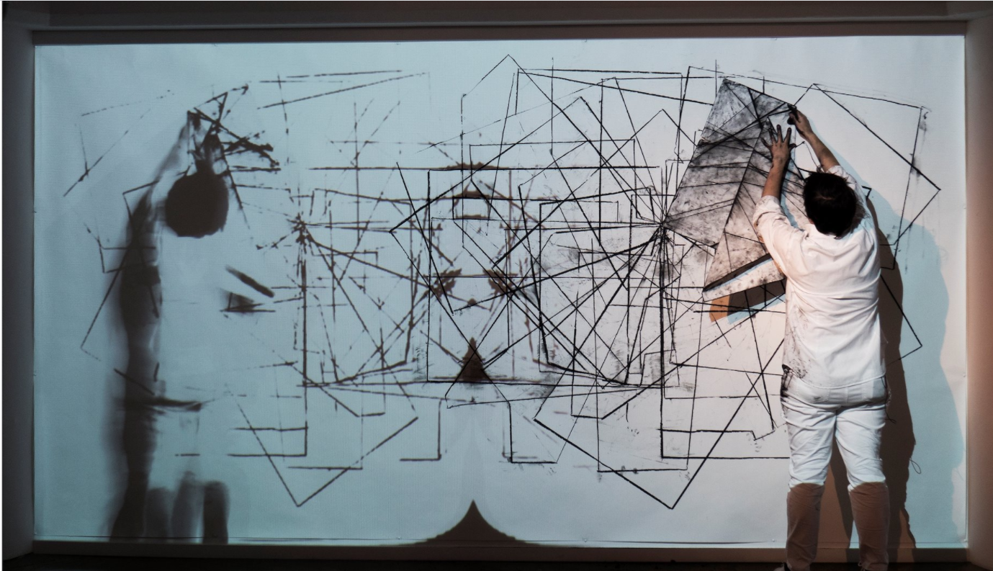
To conclude, Lisa Munnelly and Nicola Farquhar give us a greater understanding of Material Thinking through their work and in their relationship they have to their materials. They show how Material Thinking comes from the making process, where things are in motion, the unconscious and conscious mind come together, in a process of becoming, a joining of past embodied knowledge and the present moment. Lisa Munnelly and Nicola Farquhar treat their materials with a Material Thinking perspective as if they have a lifeforce, giving them material agency, and ability to converse. Ultimately they show us how the visual language is one to be experienced and felt through our senses, one where Material Thinking becomes more about the thinking and experiencing of a material.
Lisa Munnelly, Dirty Edges Clean Lines, 2017, charcoal on paper, Toi Poneke Gallery, Wellington, accessed 7 October 2020, https://lisamunnelly.carbonmade.com/projects/6518641.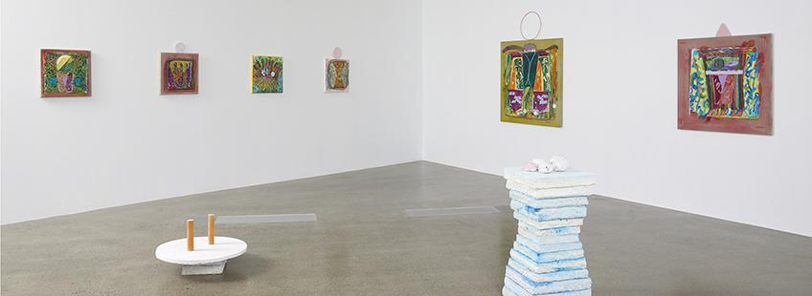Nicola Farquhar, Listening, Twitching, 2020, Installation view, Te Uru Gallery, Accessed 7 October 2020, https://www.teuru.org.nz/index.cfm/whats-on/calendar/nicola-farquhar-listening-twitching/.
Bibliography
Bennett, Jane. Vibrant Matter: A Political Ecology of Things. North Carolina, United States: Duke University Press, 2010. http://ebookcentral.proquest.com/lib/aut/detail.action?docID=1170671.
Bolt, Barbara. Art Beyond Representation: The Performative Power of the Image. London, United Kingdom: I. B. Tauris & Company, Limited, 2004. http://ebookcentral.proquest.com/lib/aut/detail.action?docID=676616.
Carter, Paul. Material Thinking : The Theory and Practice of Creative Research. Melbourne University Press, 2004.
Crowther, Paul. The Language of Twentieth-Century Art: A Conceptual History. London: Yale University Press, 1997.
Geoghegan, Chloe. Interview with Nicola Farquhar, 2020. https://www.teuru.org.nz/teuru/assets/File/Exhibitions%202020/Nicola%20Farquhar/Te%20Uru_Nicola%20Farquhar%20interview.pdf.
Geoghegan, Chloe. ‘Nicola Farquhar Roomsheet’. Te Uru Gallery. Accessed 3 October 2020. https://www.teuru.org.nz/teuru/assets/File/Nicola%20Farquhar%20Roomsheet.pdf.
Lane, Chloe. ‘The Writer and the Artist’. The Spinoff (blog), 29 June 2020. https://thespinoff.co.nz/books/29-06-2020/the-writer-and-the-artist/.
Lefebvre, Henri, Catherine Régulier, and Mohamed Zayani. ‘The Rhythmanalytical Project’. Rethinking Marxism 11, no. 1 (March 1999): 5–13. https://doi.org/10.1080/08935699908685562.
Minissale, Gregory. The Psychology of Contemporary Art. New York: Cambridge University Press, 2013.
Munnelly, Lisa. Dirty Edges and Clean Lines, 2018. https://www.youtube.com/watch?v=_D1eGx_zBY0.
Munnelly, Lisa. ‘Dialogues in Proximity’. Studies in Material Thinking Vol 4 (September 2010). https://www.materialthinking.org/sites/default/files/papers/LisaMunnelly.pdf.
Munnelly, Lisa. ‘Dirty Edges Clean Lines’. Accessed 7 October 2020. https://lisamunnelly.carbonmade.com/projects/6518641.
Munnelly, Lisa. ‘WRITING upon DIRTY EDGES and CLEAN LINES’. Performance Research 23, no. 2 (17 February 2018): 112–15. https://doi.org/10.1080/13528165.2018.1464769.
Newton, Stephen J. Painting, Psychoanalysis, and Spirituality. Newcastle, UK: Cambridge University Press, 2001.
O’Sullivan, Simon. ‘THE AESTHETICS OF AFFECT: Thinking Art beyond Representation’. Angelaki 6, no. 3 (December 2001): 125–35. https://doi.org/10.1080/09697250120087987.
Pippo, Alexander Di. ‘The Concept of Poiesis in Heidegger’s An Introduction to Metaphysics’, n.d., 33.
Pollock, Jackson. ‘My Painting’. Possibilities, Wittenborn, Schultz, Inc., no. 1 (Winter 1947).
Te Uru Gallery, ‘Nicola Farquhar: Listening, Twitching - Te Uru’. Accessed 7 October 2020. https://www.teuru.org.nz/index.cfm/whats-on/calendar/nicola-farquhar-listening-twitching/.
Tonkinwise, Cameron. ‘Knowing by Being-There Making: Explicating the Tacit Post-Subject in Use’, Studies in Material Thinking, Vol. 1, no. No. 2 (April 2008). http://www.materialthinking.org.
Whitehead, Derek H. ‘Poiesis and Art-Making: A Way of Letting-Be’. Contemporary Aesthetics 1 (2003). http://hdl.handle.net/2027/spo.7523862.0001.005.

Geoghegan, Chloe, Interview with Nicola Farquhar, 2020, https://www.teuru.org.nz/teuru/assets/File/Exhibitions%202020/Nicola%20Farquhar/Te%20Uru_Nicola%20Farquhar%20interview.pdf.
Minissale, Gregory, The Psychology of Contemporary Art (New York: Cambridge University Press, 2013), pg 162.
Minissale, Gregory, The Psychology of Contemporary Art (New York: Cambridge University Press, 2013), Pg 166
Geoghegan, Chloe, Interview with Nicola Farquhar, 2020, https://www.teuru.org.nz/teuru/assets/File/Exhibitions%202020/Nicola%20Farquhar/Te%20Uru_Nicola%20Farquhar%20interview.pdf.
Crowther, Paul, The Language of Twentieth-Century Art: A Conceptual History (London: Yale University Press, 1997), pg 169
Jane Bennett, Vibrant Matter: A Political Ecology of Things (North Carolina, United States: Duke University Press, 2010), http://ebookcentral.proquest.com/lib/aut/detail.action?docID=1170671.
https://thespinoff.co.nz/books/29-06-2020/the-writer-and-the-artist/
Lisa Munnelly, ‘WRITING upon DIRTY EDGES and CLEAN LINES’, Performance Research 23, no. 2 (17 February 2018): 112–15, https://doi.org/10.1080/13528165.2018.1464769.
Ibid.
Paul Carter, Material Thinking : The Theory and Practice of Creative Research (Melbourne University Press, 2004).
Paul Carter, Material Thinking : The Theory and Practice of Creative Research (Melbourne University Press, 2004).
Dirty Edges and Clean Lines, Lisa Munnelly, 2018, https://www.youtube.com/watch?v=_D1eGx_zBY0, 18.12.
Lisa Munnelly, ‘WRITING upon DIRTY EDGES and CLEAN LINES’, Performance Research 23, no. 2 (17 February 2018): 112–15, https://doi.org/10.1080/13528165.2018.1464769.
Ibid.
Simon O’Sullivan, ‘THE AESTHETICS OF AFFECT: Thinking Art beyond Representation’, Angelaki 6, no. 3 (December 2001): 125–35, https://doi.org/10.1080/09697250120087987.
Geoghegan, Chloe, Interview with Nicola Farquhar, 2020, https://www.teuru.org.nz/teuru/assets/File/Exhibitions%202020/Nicola%20Farquhar/Te%20Uru_Nicola%20Farquhar%20interview.pdf.
Jane Bennett, Vibrant Matter: A Political Ecology of Things (North Carolina, United States: Duke University Press, 2010), http://ebookcentral.proquest.com/lib/aut/detail.action?docID=1170671, pg 143
Paul Carter, Material Thinking : The Theory and Practice of Creative Research (Melbourne University Press, 2004).
Ibid, 8:34
Munnelly, Lisa, ‘Dialogues in Proximity’, Studies in Material Thinking Vol 4 (September 2010), https://www.materialthinking.org/sites/default/files/papers/LisaMunnelly.pdf.
Heimer, Astrid, ‘The Aesthetics of Form Knowledge: Embodied Knowledge through Materialization’, Studies in Material Thinking, Vol 14 (April 2016), http://www.materialthinking.org/sites/default/files/papers/0176_SMT_V14_P04_FA.pdf.
Paul Carter, Material Thinking : The Theory and Practice of Creative Research (Melbourne University Press, 2004), pg 5.
Geoghegan, Chloe, ‘Nicola Farquhar Roomsheet’ (Te Uru Gallery), accessed 3 October 2020, https://www.teuru.org.nz/teuru/assets/File/Nicola%20Farquhar%20Roomsheet.pdf.

